# **Lab: Active Directory**

## **Overview**

ADAC (Active Directory Administrative Center) facilitates the convenient administration of user profiles from any Windows endpoint that can achieve connectivity with the DC. This application acts as a user identity control panel capable of many tasks ranging from user creation to simple password changes.

In order to issue group policy and allow users of Windows endpoints to access their AD profile, you’ll need to join those endpoints to the domain.

## **Scenario**

The project to transition GlobeX to a domained system was originally motivated by a need to standardize computer configurations across the organization. The next task is to join GlobeX endpoints to the new DC.

## **Objectives**

* Join the Windows 10 endpoint to the newly-created domain
* Configure ADAC on the Windows 10 endpoint for use by the systems administrator
* Create the following user accounts on ADAC
  + Francis Hopkins, Sr. Account Executive, Sales Department, GlobeX USA
  + Amanda Williams, HR Specialist, HR, GlobeX USA
  + Jim Sanders, HR Manager, HR, GlobeX USA
  + Rita Morgan, CFO, Finance, GlobeX USA
  + Yourself, Systems Administrator, GlobeX USA
* Create OUs by department.
* Sign into the Windows 10 endpoint using each AD profile

## **Resources**

* [Microsoft Documentation - Active Directory Administrative Center](https://docs.microsoft.com/en-us/windows-server/identity/ad-ds/get-started/adac/active-directory-administrative-center)
* [Join Windows 10 to a Domain](https://www.itechguides.com/join-windows-10-to-domain/)

## **Tasks**

### **Part 1: Join Endpoint to Domain**

Join your Windows 10 endpoint to the domain. This can be done a number of ways. Here is one method:

* ~~This can be done from the This PC > Properties menu. Right click “This PC” in Windows Explorer and select Properties to access this menu.~~
* ~~Locate the button “Change…” under Computer Name tab.~~
* ~~Here under “Member of” section you can toggle into the Domain option and type the name of your domain. If you encounter errors, try entering the FQDN of your domain.~~

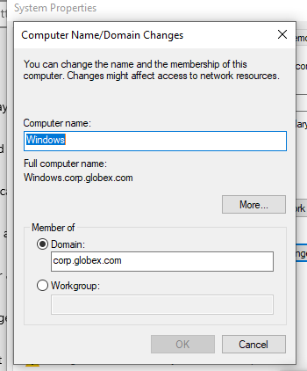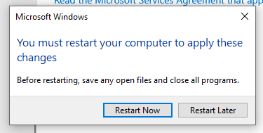

* ~~Windows will then prompt you to authenticate as CORP\Administrator (or whoever you’ve set as the domain administrator).~~

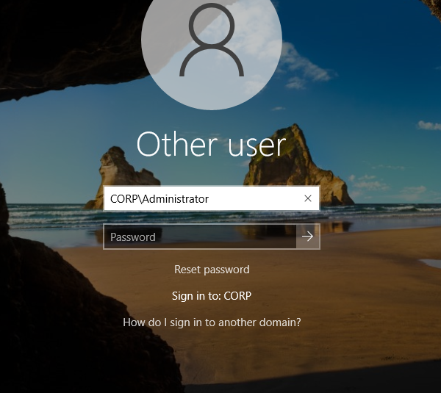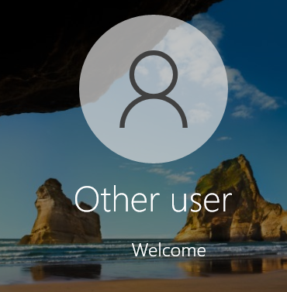

* ~~Windows will then prompt you to reboot to finalize the domain join procedure.~~

### **Part 2: AD Profile Creation & Login**

* ~~Install RSAT on the Windows 10 endpoint.~~

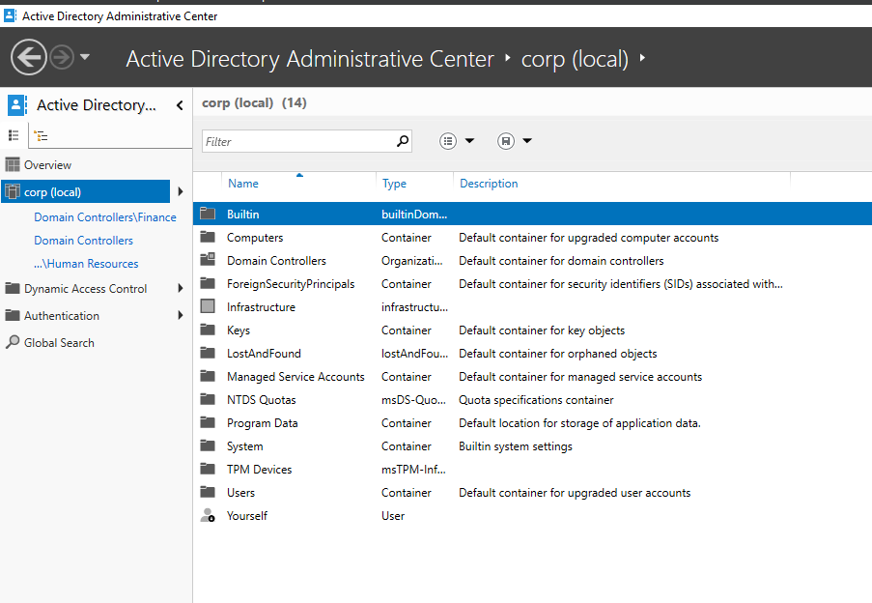

* ~~Configure ADAC to authenticate into the Windows Server.~~
* ~~In ADAC create the below users with the provided profile information.~~
  + ~~Francis Hopkins, Sr. Account Executive, Sales Department, GlobeX USA~~

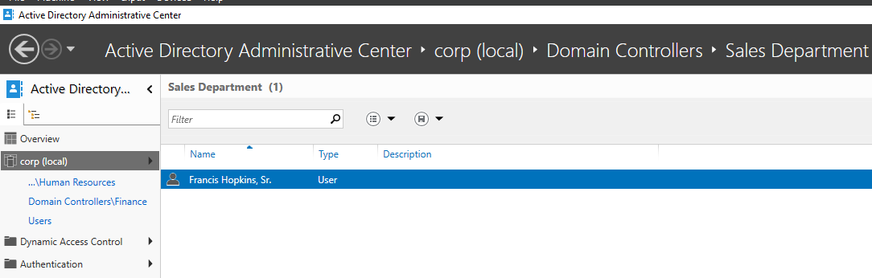

* + ~~Amanda Williams, HR Specialist, HR, GlobeX USA~~

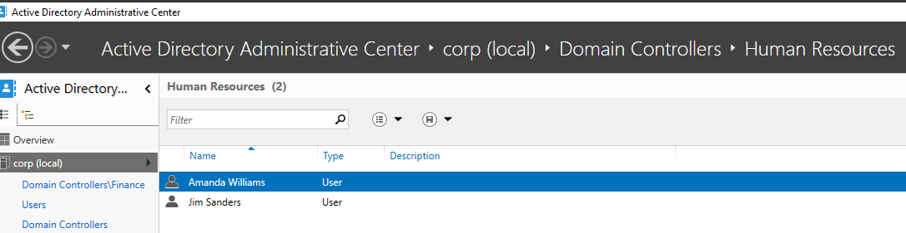

* + ~~Jim Sanders, HR Manager, HR, GlobeX USA~~



* + ~~Rita Morgan, CFO, Finance, GlobeX USA~~

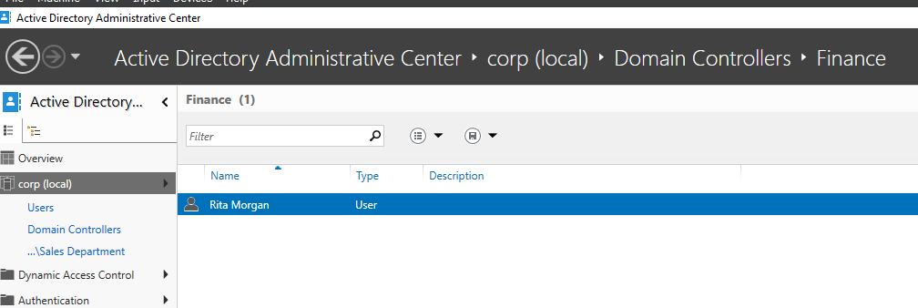

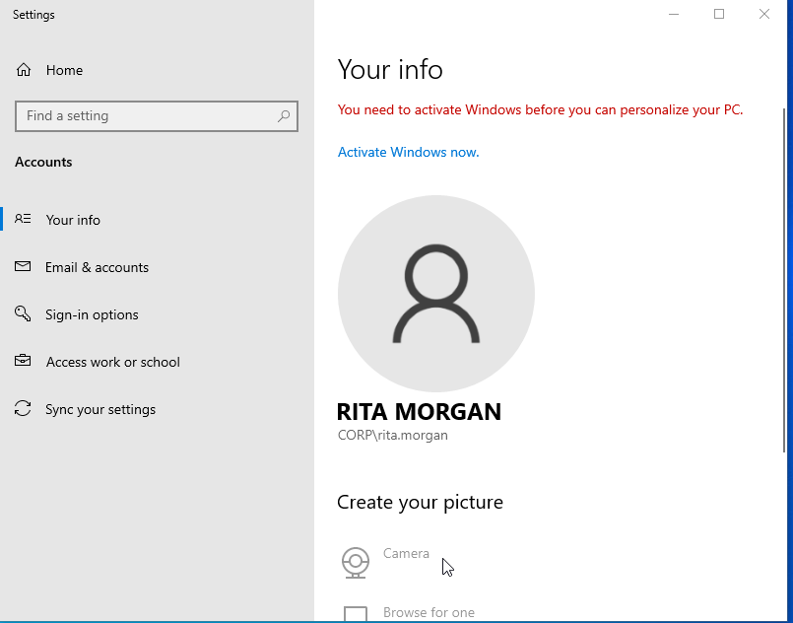

* + ~~Yourself, Systems Administrator, GlobeX USA~~

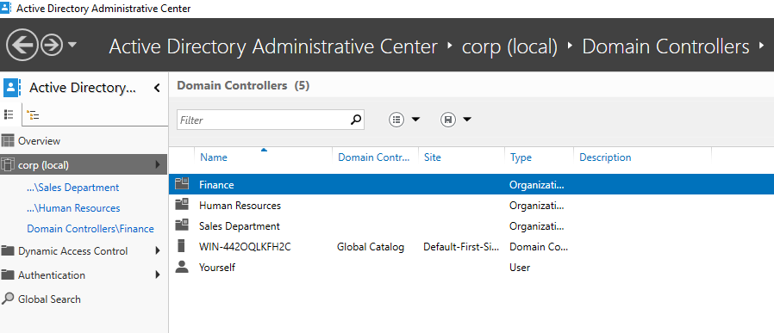

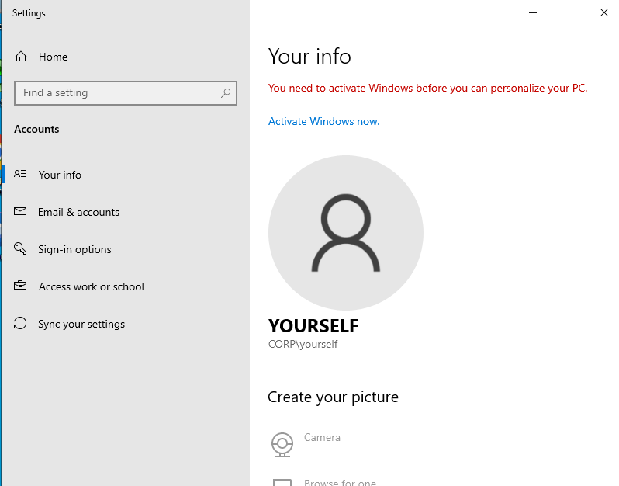

* ~~Create OUs by department.~~

**As you can see, they are all located in their respective folders**

* ~~Test that all profiles may login to the Windows 10 endpoint.~~

### **Part 3: Topology**

Update your network topology diagram with any changes made to your network.

